A

PROJECT REPORT

ON

PMPML ONLINE TICKET BOOKING SYSTEM

Submitted in partial fulfillment for the award of

Post Graduate Diploma in Advance Computing

(PG-DAC) from

INSTITUTE OF EMERGING TECHNOLOGIES

Authorized Training Centre


Under the Guidance of

BY
- ROHAN KULKARNI 250245920043
- KIRAN LAMBATE 250245920040
- AKSHAY GORE 250245920009
- SHARAYU VANJARI 250245920081
- PRATIKSHA NALAWADE 250245920065



CERTIFICATE

This is to certify that the project report entitled PMPML Online Ticket Booking System is a bonfire work carried out by
- ROHAN KULKARNI 250245920043
- KIRAN LAMBATE 250245920040
- AKSHAY GORE 250245920009
- SHARAYU VANJARI 250245920081
- PRATIKSHA NALAWADE 250245920065
and submitted in partial fulfilment of the requirement for the C-DAC ACTS, DAC course in Institute of Emerging Technology in the batch Feb 2025.

Course Coordinator External Examiner

ACKNOWLEDGEMENT

This project PMPML Online Ticket Booking System was a great learning experience for us and we are submitting this work to Advanced Computing Training School (CDAC).

We are very glad to mention the Name of the Guide for her valuable guidance to work on this project. Her guidance and support helped us to overcome various obstacles and intricacies during the course of project work.

Our most heart full thanks goes to Mr. Sangram Patil (Director ,IET)who gave all the required support and kind coordination to provide all the necessities like required hardware , internet facility and extra lab hours to complete the project and throughout the course up to the last day here in C-DAC ACTS, Pune.

- ROHAN KULKARNI 250245920043
- KIRAN LAMBATE 250245920040
- AKSHAY GORE 250245920009
- SHARAYU VANJARI 250245920081
- PRATIKSHA NALAWADE 250245920065

Abstract

The PMPML (Pune Mahanagar Parivahan Mahamandal Limited) Online Ticket Booking Project is a digital initiative aimed at modernizing public bus transportation in Pune by providing commuters with a seamless, cashless, and paperless ticketing experience. The project centers around a dedicated mobile application that allows users to book bus tickets, access real-time transit information, and plan their journeys efficiently.

The primary objective of the PMPML Online Ticket Booking Project is to digitally transform the public bus ticketing system in Pune, making it more convenient, efficient, and user-friendly for commuters. The project aims to achieve the following specific goals:

1.Enhance Passenger Convenience

2.Promote Cashless and Paperless Transactions

3.Improve Service Transparency and Reliability

4.Increase Operational Efficiency

5.Enhance Flexibility for Commuters

6.Strengthen Customer Support

Index

Sr. No. | Title | Page No.
1 | Introduction
2 | Problem Definition & Scope
2.1 | Problem Definition
2.2 | Goals & Objectives
2.3 | Major Constraints& Outcomes
3 | Software Requirement Specification
3.1 | Purposed System
3.2 | Scope
4 | System Modules
5 | Performance-Requirements
5.1 | H/W Requirements & S/W Requirements
6 | UML Diagram
6.1 | DFD
6.2 | ERD
6.3 | Use case diagram
6.4 | Class Diagram
6.5 | Sequence diagram
6.6 | Activity Diagram
6.7 | Deployment diagram
6.8 | System Architecture
7 | Test Cases
8 | Screenshots
9 | References

INTRODUCTION

PROBLEM DEFINITION AND SCOPE

The current PMPML online ticket booking system, while a step towards modernization, still has significant limitations that impact user experience and operational efficiency:

Limited Functionality: The system primarily supports only basic features such as online ticket booking and digital payments. Advanced features that enhance convenience and accessibility are missing.

Time-Bound Ticket Validity: Tickets booked online are valid for only a short period (typically 3 hours). This restricts flexibility for passengers who may need to plan their journeys in advance or face unexpected delays.

No Multilingual Support: The application and ticketing interface are available only in a single language (usually English or Marathi), making it less accessible for non-native speakers and tourists.

Lack of Digital QR Ticket Generation: While QR codes are used for payment processing, the system does not generate a digital QR code ticket for passengers that can be scanned for self-validation upon boarding. Tickets are still issued by conductors after payment, which limits the advantages of a fully digital and contactless system.

Inconvenience for Passengers: The above limitations mean that passengers still face challenges such as language barriers, lack of flexibility in ticket usage, and partial digitalization of the ticketing process.

Missed Opportunities for Accessibility and Security: Absence of features like multilingual support and digital ticket validation reduces the system’s inclusivity and potential for fraud prevention.

Software Requirements and Specifications

(Front End: React | Back End: .NET | Database: MySQL)

- Front End:

React Requirements:

ReactJS (latest stable version)

Node.js (for development/build)

Responsive, accessible UI

Integration with RESTful APIs

- Back End:

.NET Requirements:

.NET 6 or higher (ASP.NET Core)

RESTful API development

Entity Framework Core (ORM)

JWT/OAuth authentication

Payment gateway integration

- Database:

MySQL Requirements:

MySQL Community Server 8.x

Secure connection (SSL/TLS)

Regular backups

4. Deployment Tools: AWS

5. API Provider: Payment Gateway API: Razorpay
UML Diagrams
UML Diagrams

- Use case diagram

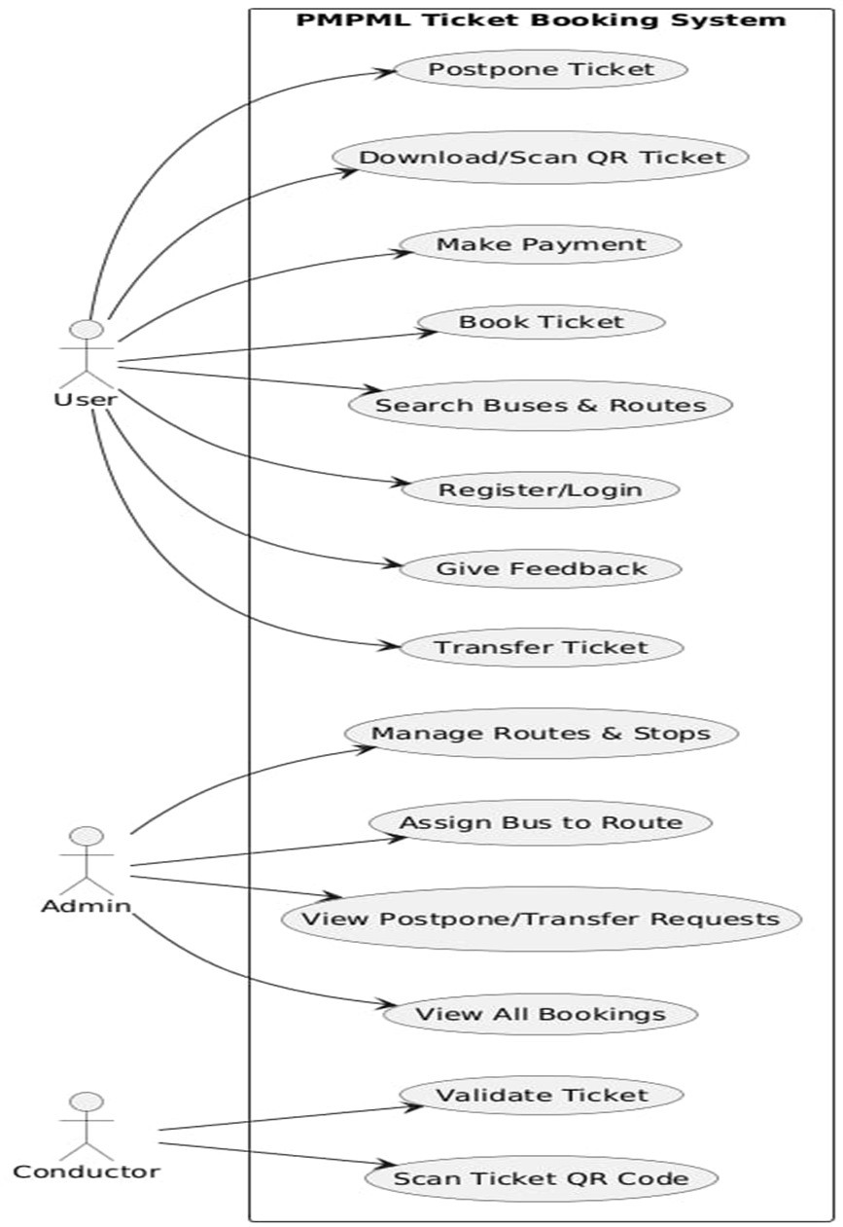

- Class diagram

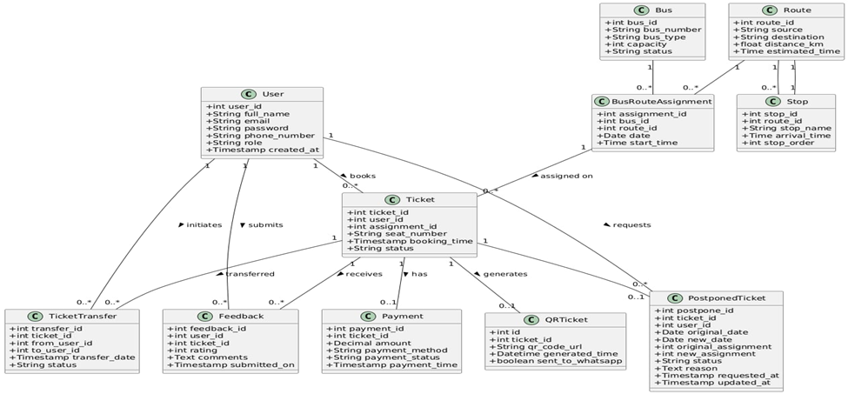

- Sequence diagram

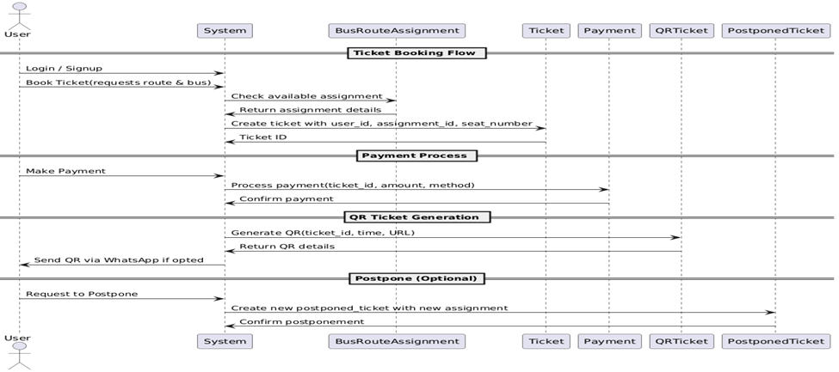

- Activity diagram

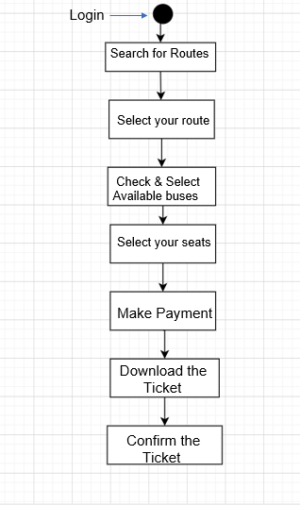

- Dataflow diagram

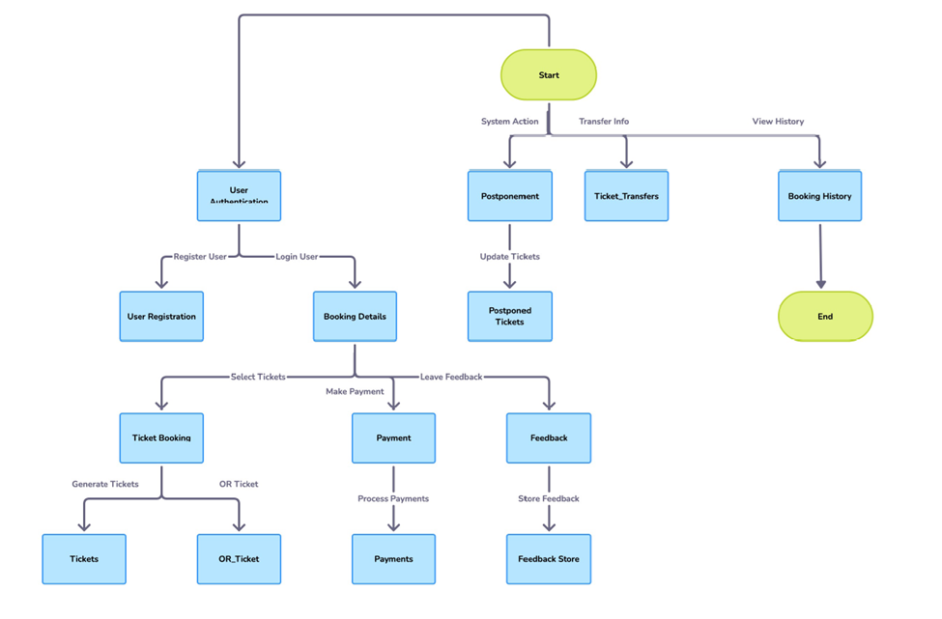

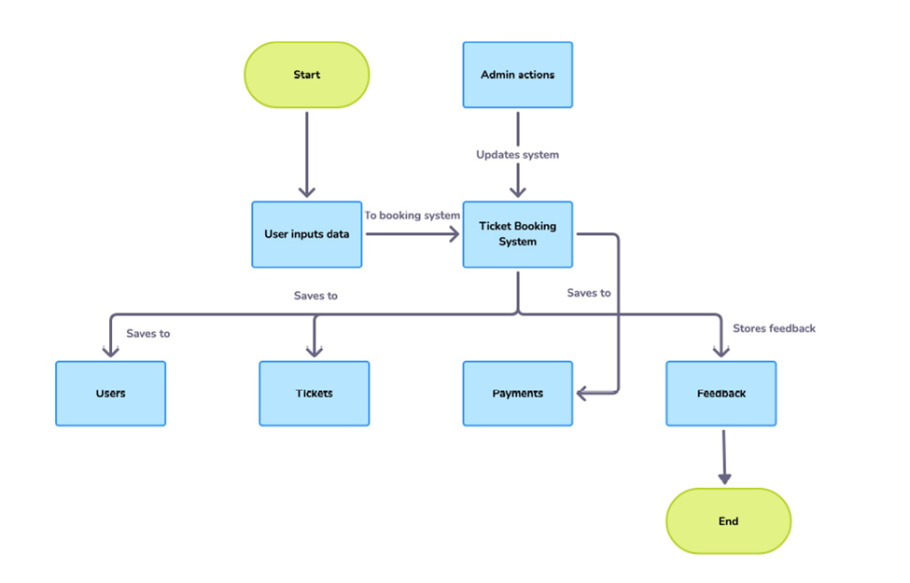

6) ER diagram

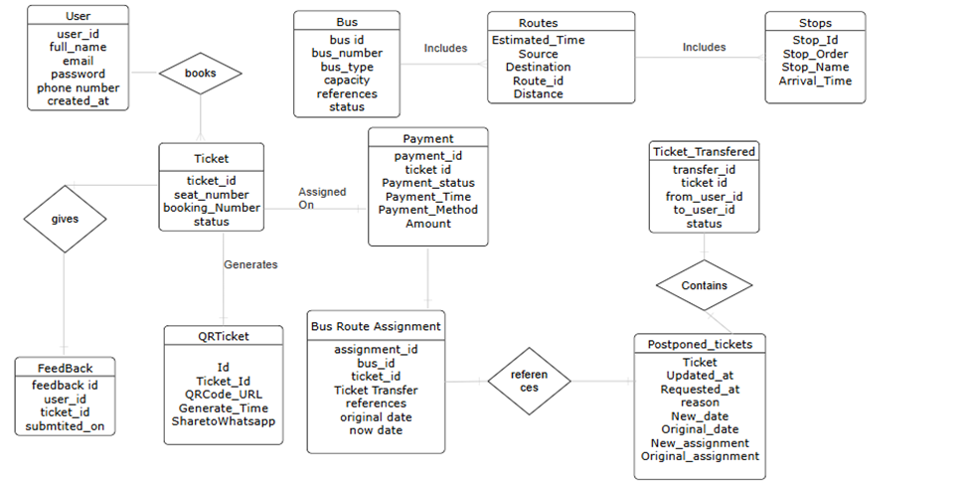

User Interface of the Project

- Login page

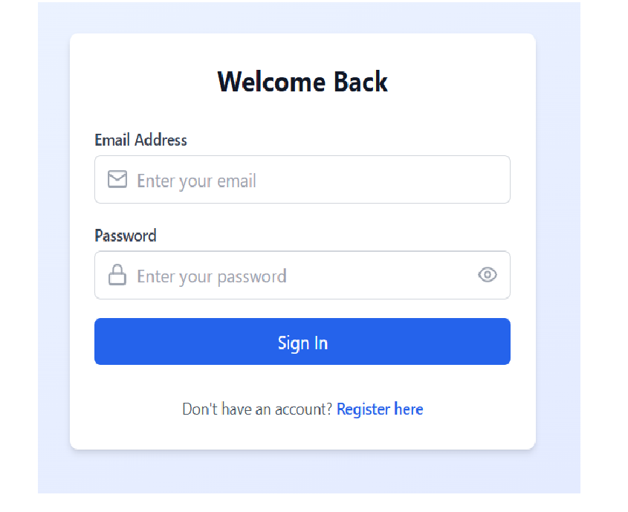

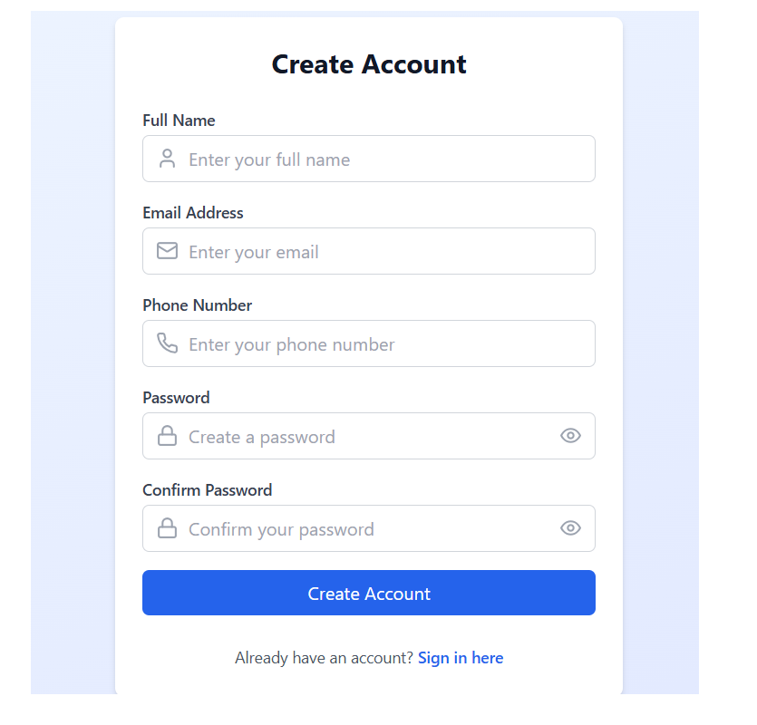

- Search Routes

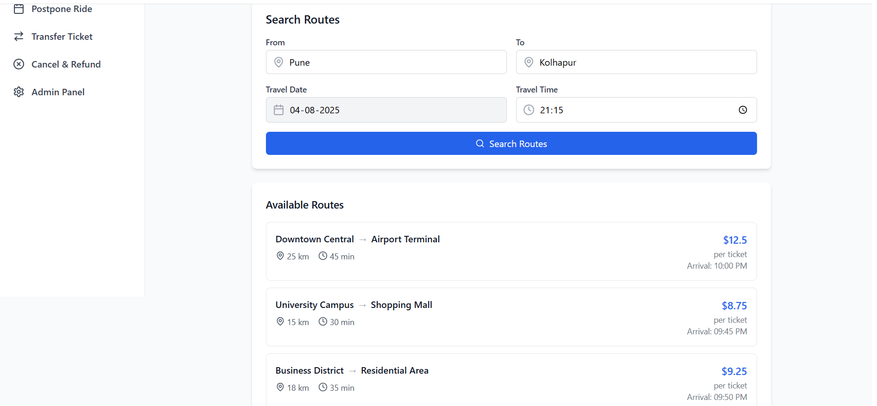

- Available Buses

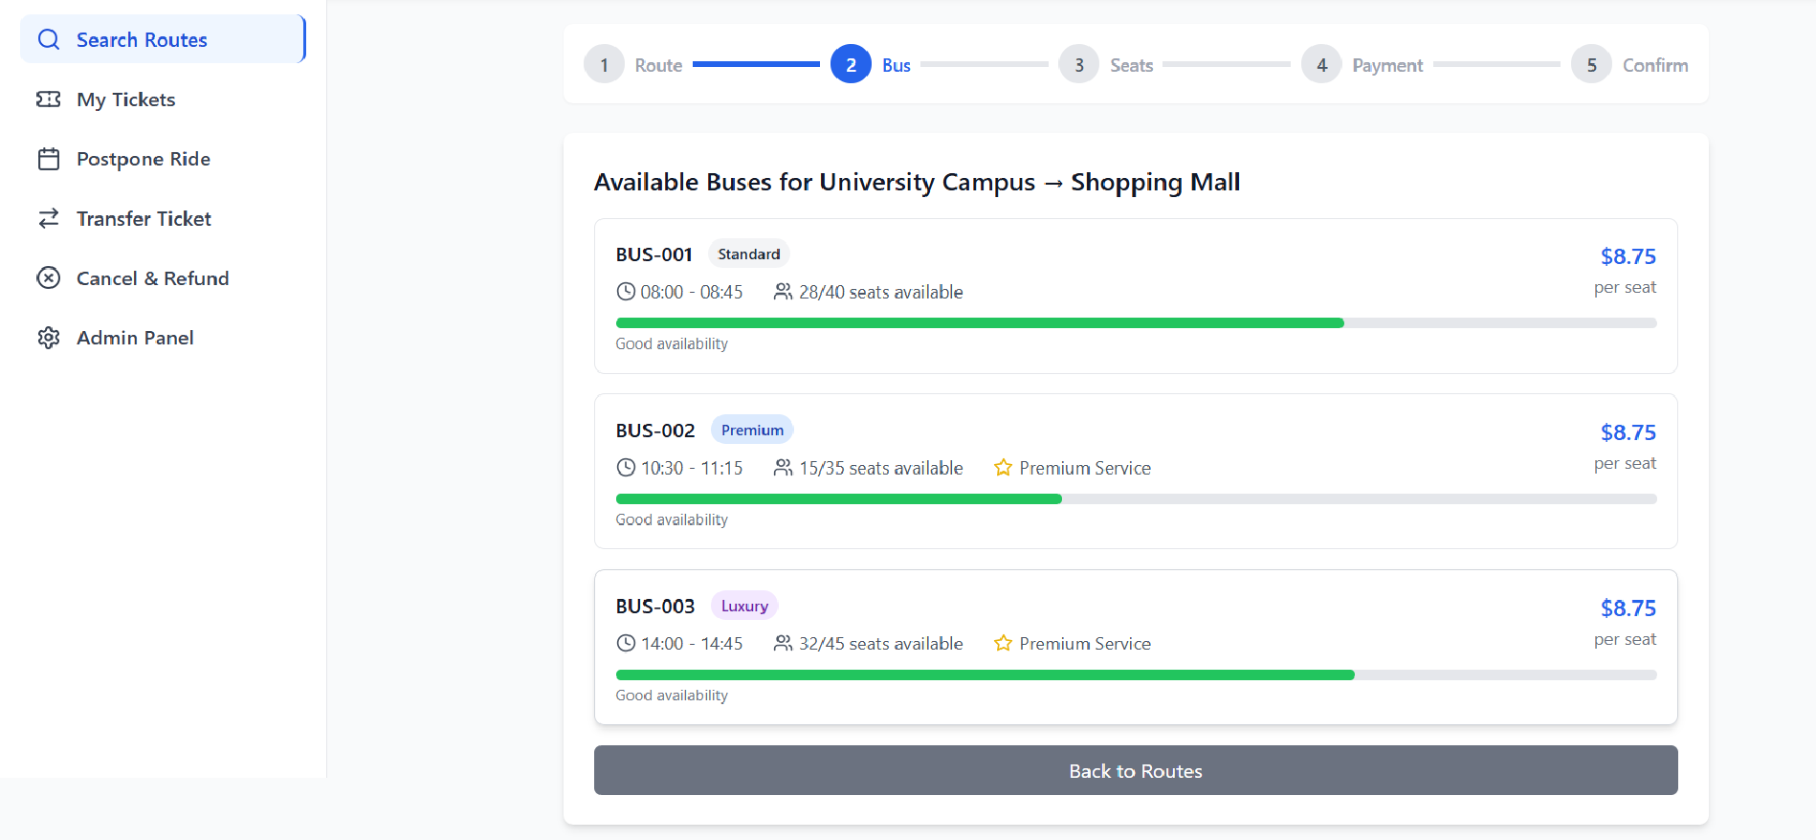

- Selection of Buses

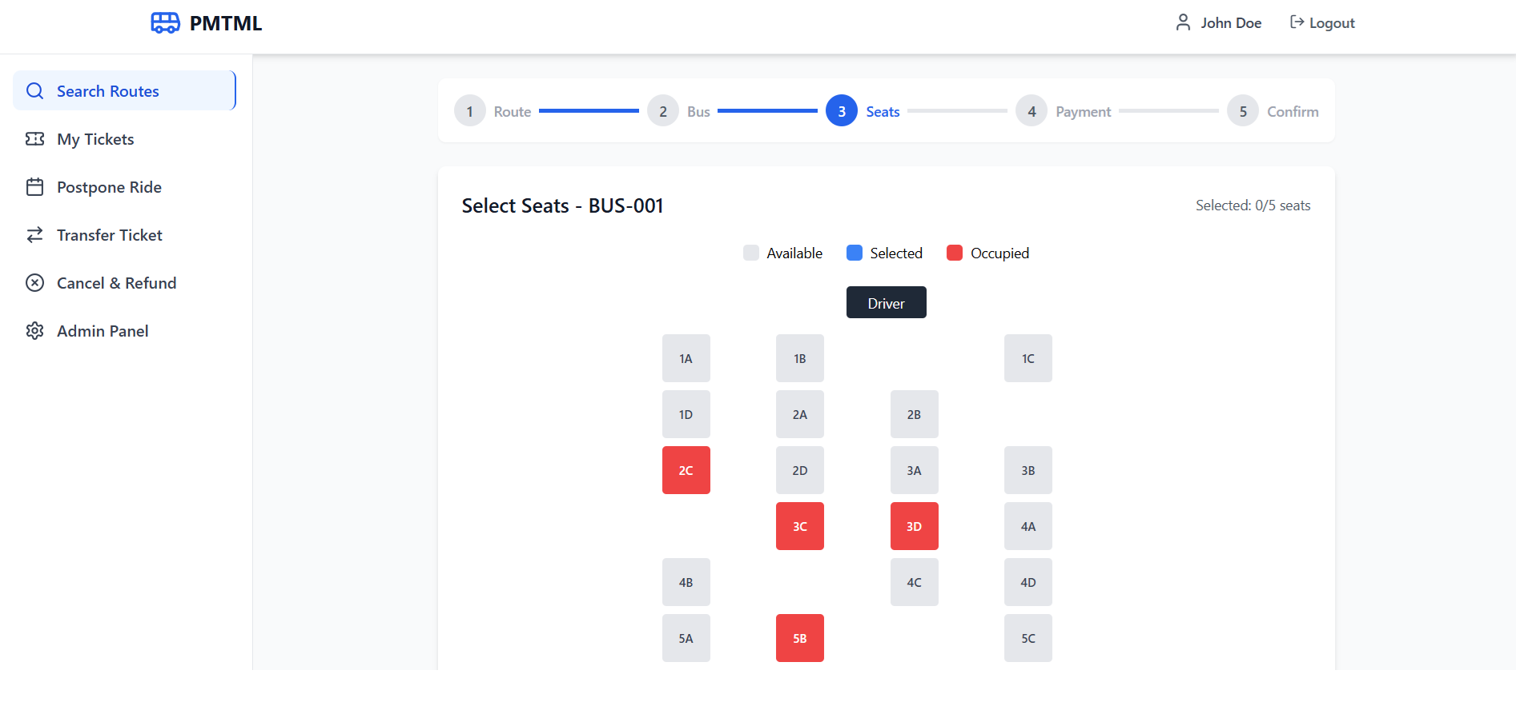

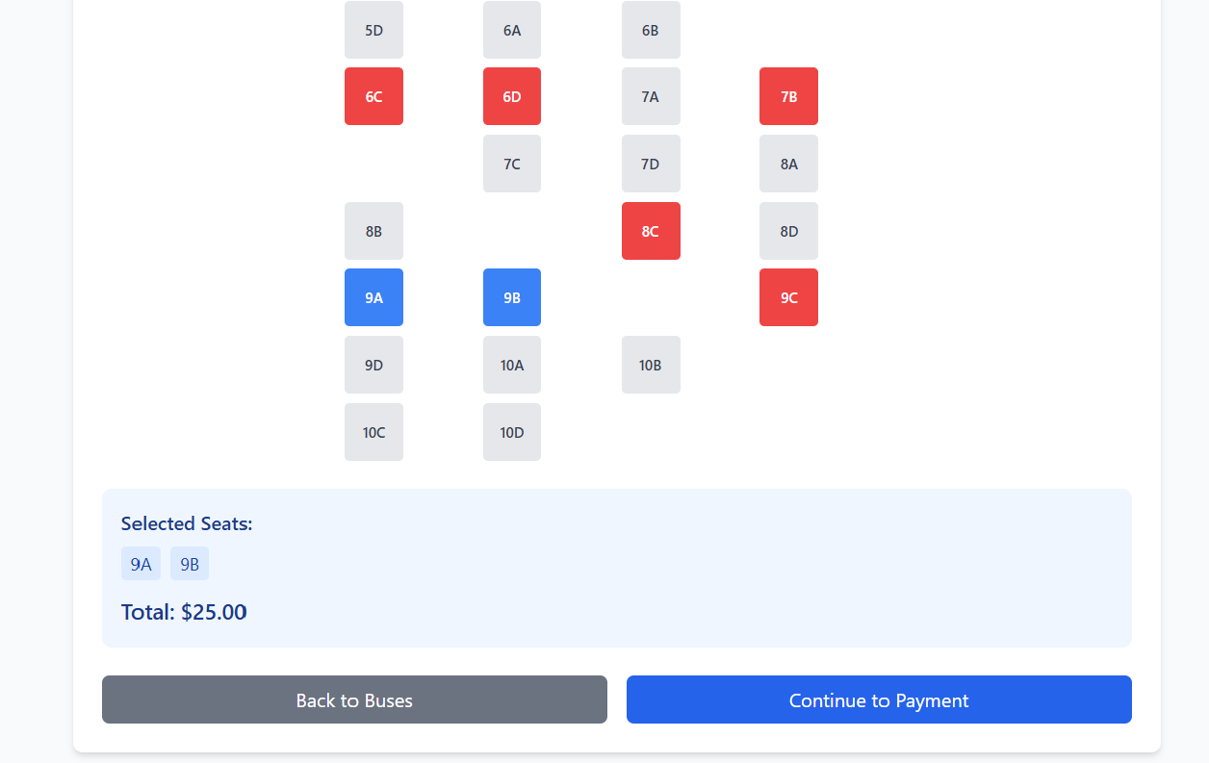

- Making Payment

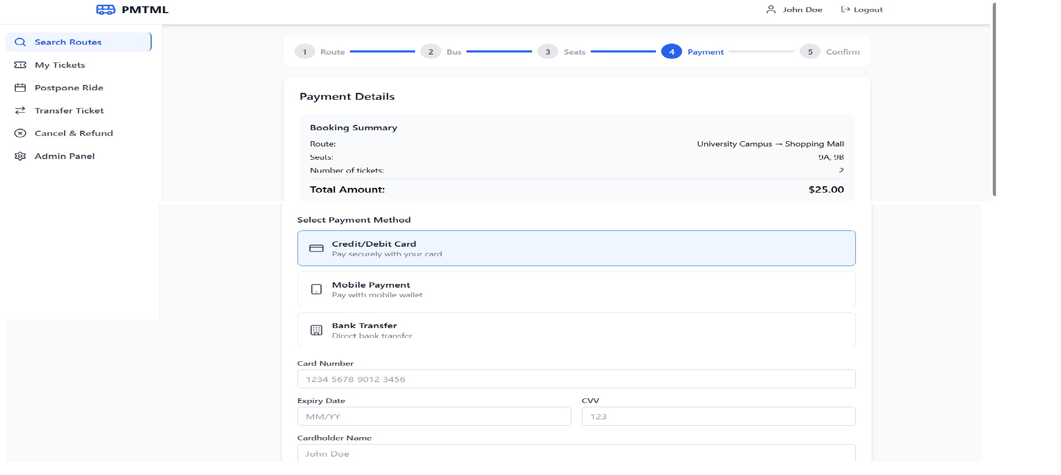

- Download Ticket

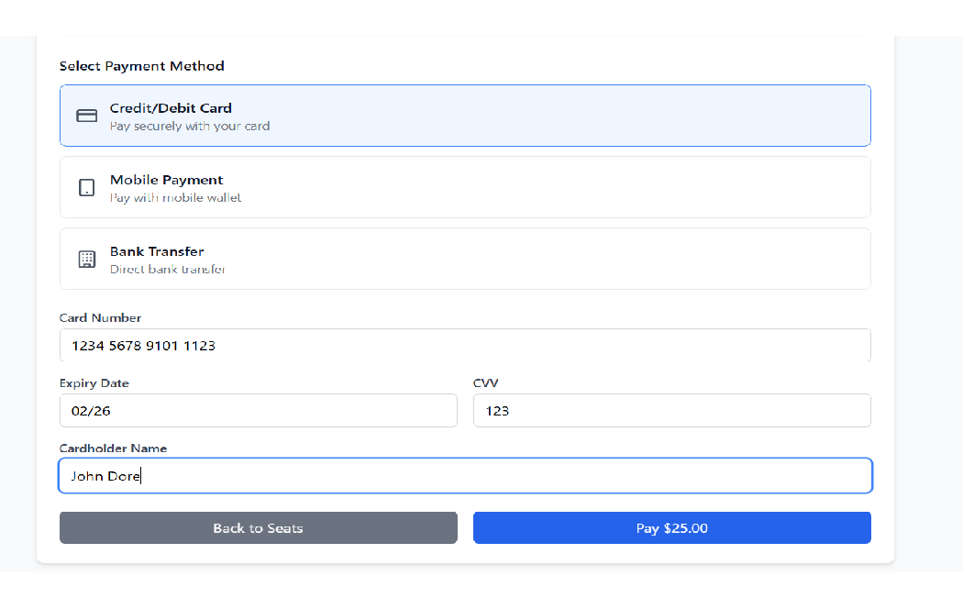

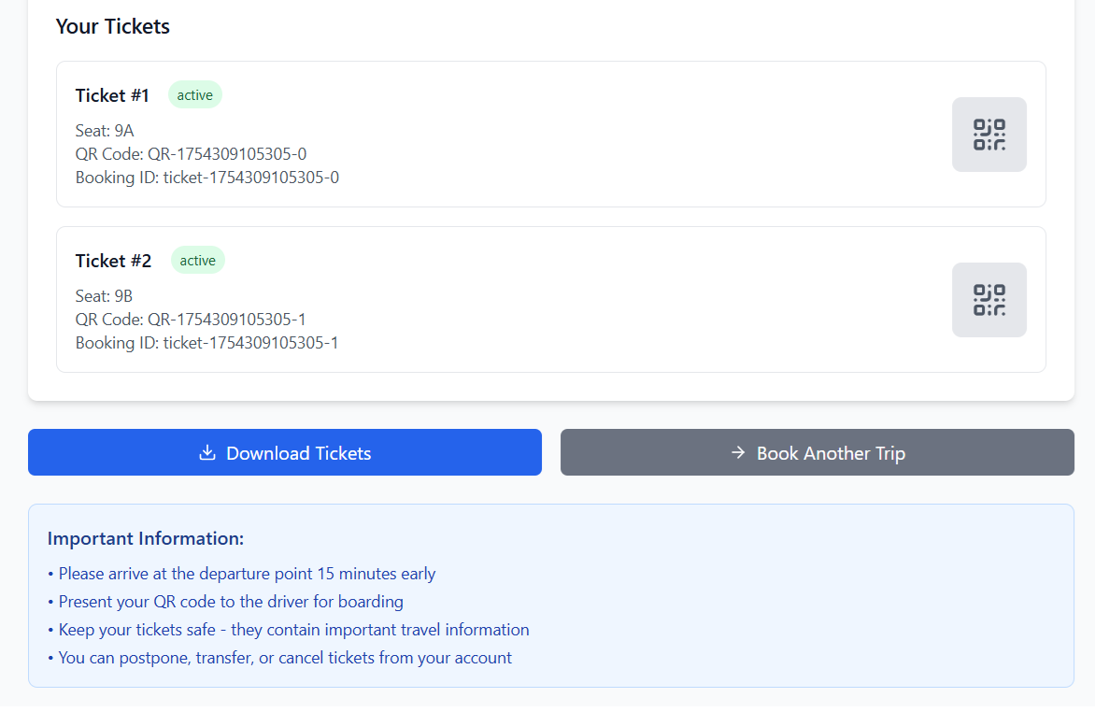

- My Ticket

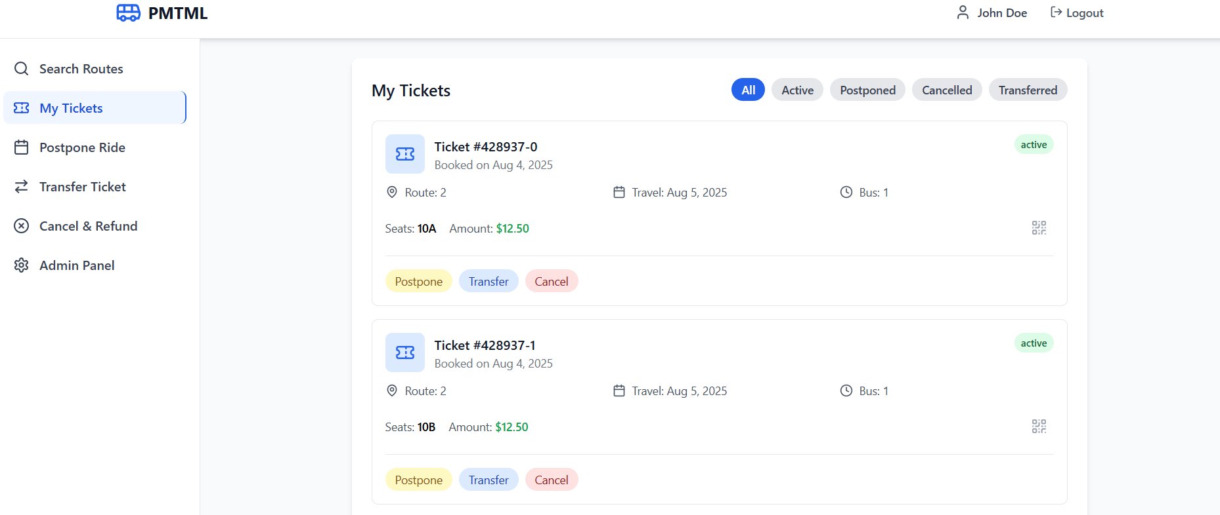

- Transfer Ticket

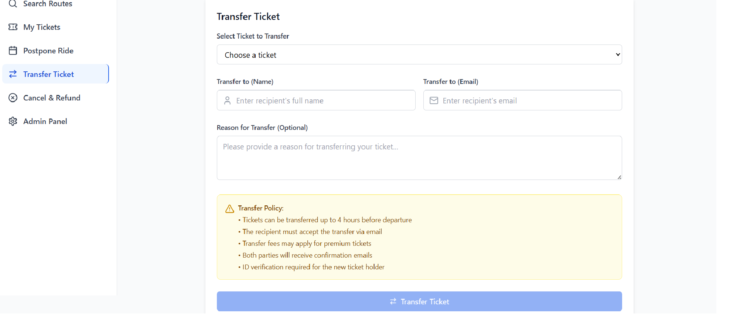

- Cancel & Refund

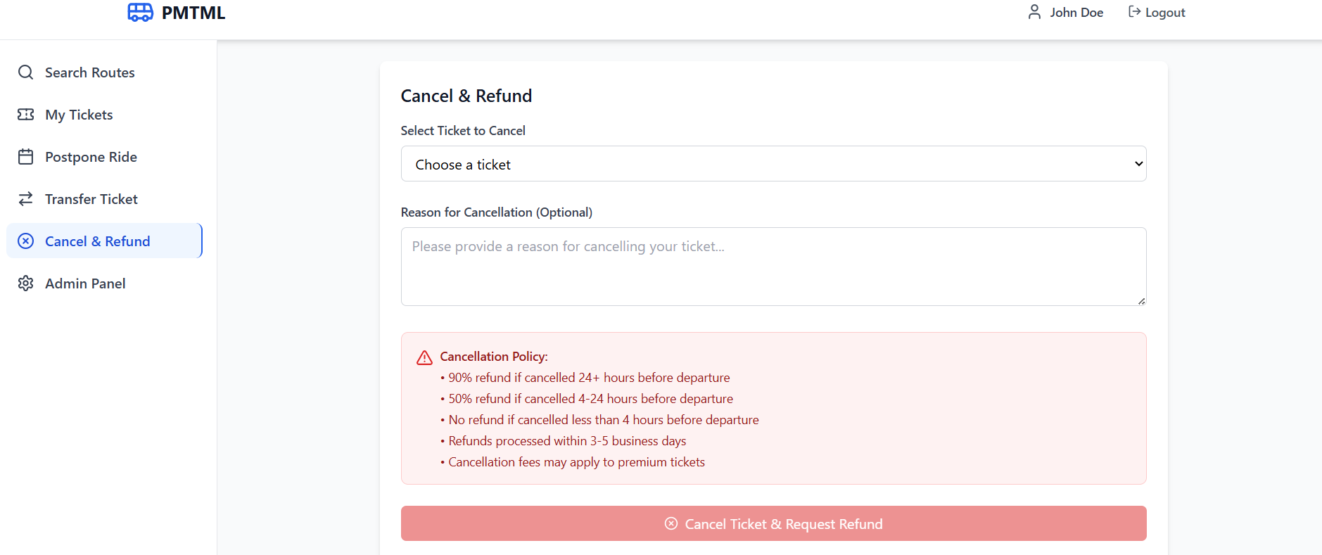

- Admin Panel

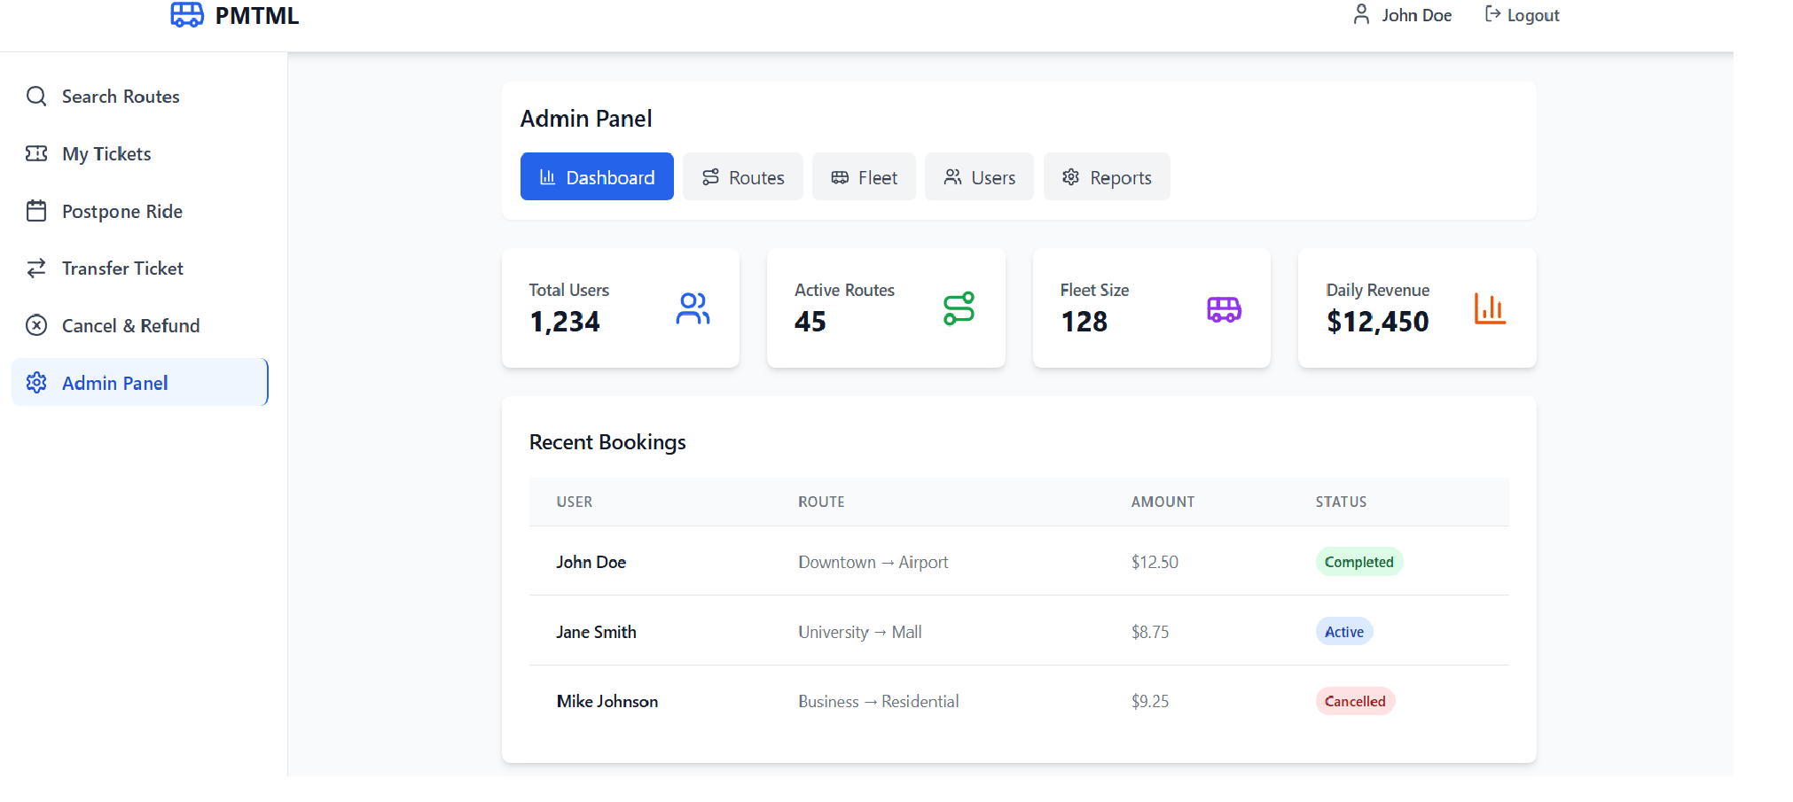

FUTURE SCOPE

- Enhanced Accessibility

- Offline Functionality

- Enhanced Security and Compliance

- Real-Time Communication

- Green Initiatives

CONCLUSION

The PMPML Online Ticket Booking Project marks a significant leap forward in modernizing Pune’s public transportation system. By leveraging advanced technologies such as React for the frontend, .NET for the backend, and MySQL for data management, the platform delivers a seamless, secure, and user-friendly experience for commuters. Key features like digital ticketing, QR code validation, ticket transfer, resale, postponement, cancellation, and real-time bus tracking collectively address the evolving needs of urban travellers.

